Object-Oriented Programming

Lecturer: NGUYEN Thi Thu Trang, [trangntt@soict.hust.edu.vn](mailto:trangntt@soict.hust.edu.vn)

Teaching Assistant: TRINH Thu Hai, [hai.tt184255@sis.hust.edu.vn](mailto:hai.tt184255@sis.hust.edu.vn)

**Lab 05: GUI Programming**

In this lab, you will practice with:

* Create simple GUI applications with Swing
* Create simple GUI applications with JavaFX
* Convert the Aims Project from the console/command-line (CLI) application to the GUI one
* Use Exception in your program

# Assignment Submission

For this lab class, you will have to turn in your work twice, specifically:

* **Right after the class**: for this deadline, you should include any work you have done within the lab class.
* **10PM five days after the class**: for this deadline, you should include the **source code** of all sections of this lab, into a branch namely “**release/lab05**” of the valid repository.

After completing all the exercises in the lab, you have to update the use case diagram and the class diagram of AIMS project.

Each student is expected to turn in his or her own work and not give or receive unpermitted aid. Otherwise, we would apply extreme methods for measurement to prevent cheating. Please write down answers for all questions into a text file named “**answers.txt”** and submit it within your repository.

# Swing components

**Note**: For this exercise, you will create a new Java project named GUIProject, and put all your source code in a package called “**hust.soict.globalict.swing**” (for ICT) or “**hust.soict.dsai.swing**” (for DS & AI).

In this exercise, we revisit the elements of the Swing API and compare them with those of AWT through implementing the same mini application using the two libraries. The application is an accumulator which accumulates the values entered by the user and display the sum.

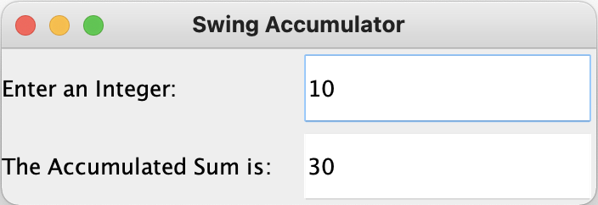

Figure . SwingAccumulator

## **AWTAccumulator**

### Create class AWTAccumulator with the source code as below

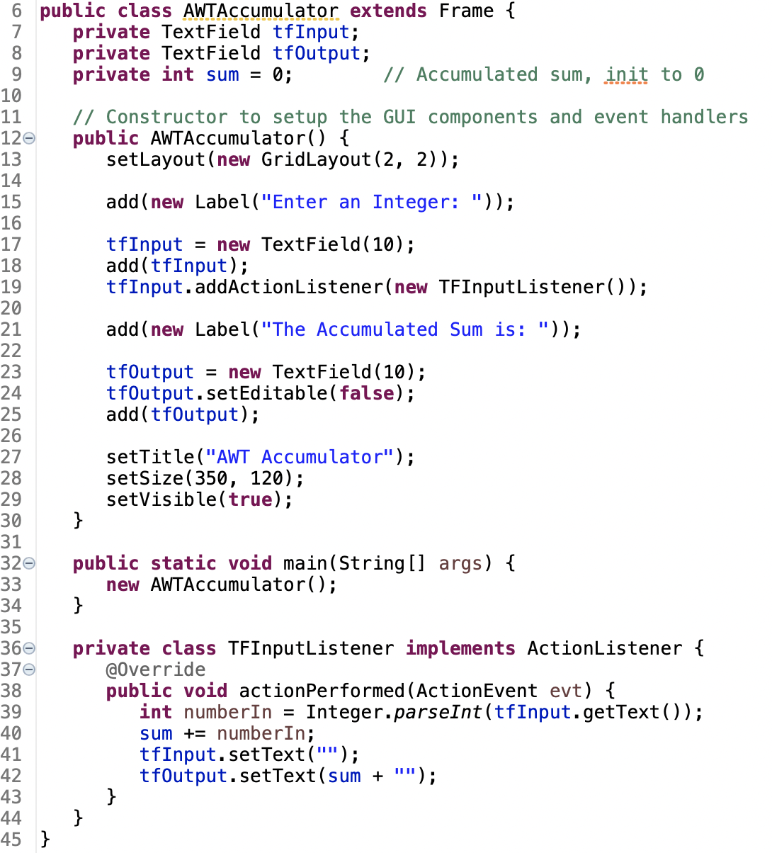

Figure . Source code of AWTAccumulator

### Explanation

* In AWT, the top-level container is Frame, which is inherited by the application class.
* In the constructor, we set up the GUI components in the Frame object and the event-handling:
* In line 13, the layout of the frame is set as GridLayout
* In line 15, we add the first component to our Frame, an anonymous Label
* In line 17-19, we add a TextField component to our Frame, where the user will enter values. We add a listener which takes this TextField component as the source, using a named inner class.
* In line 21, we add another anonymous Label to our Frame
* In line 23 – 25, we add a TextField component to our Frame, where the accumulated sum of entered values will be displayed. The component is set to read-only in line 24.
* In line 27 – 29, the title & size of the Frame is set, and the Frame visibility is set to true, which shows the Frame to us.
* In the listener class (line 36 - 44), the actionPerformed() method is implemented, which handles the event when the user hit “Enter” on the source TextField.
  + In line 39-42, the entered number is parsed, added to the sum, and the output TextField’s text is changed to reflect the new sum.
* In the main() method, we invoke the AWTAccumulator constructor to set up the GUI

## **SwingAccumulator**

### Create class SwingAccumulator with the source code as below:

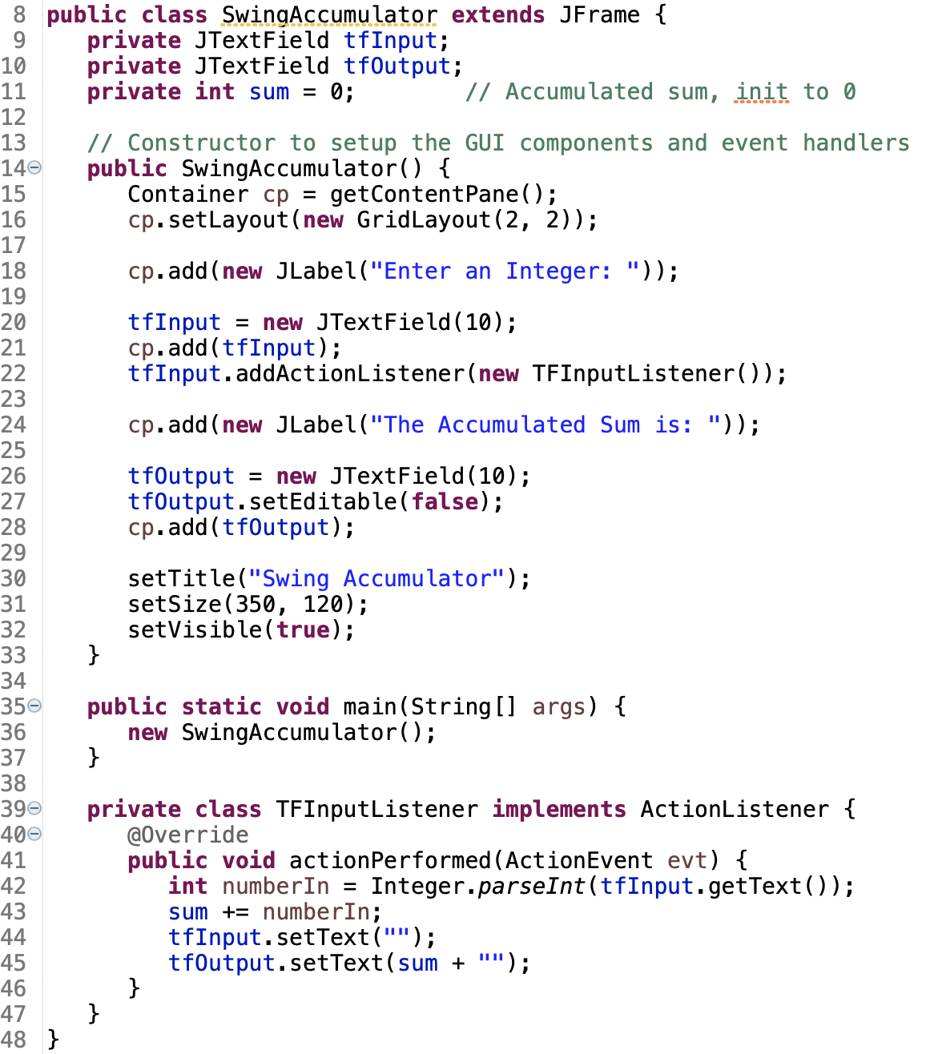

Figure . Source code of SwingAccumulator

### Explanation

* In Swing, the top-level container is JFrame which is inherited by the application class.
* In the constructor, we set up the GUI components in the JFrame object and the event-handling:
* Unlike AWT, the JComponents shall not be added onto the top-level container (e.g., JFrame, JApplet) directly because they are lightweight components. The JComponents must be added onto the so-called content-pane of the top-level container. Content-pane is in fact a java.awt.Container that can be used to group and layout components.
* In line 15, we get the content-pane of the top-level container.
* In line 16, the layout of the content-pane is set as GridLayout
* In line 18, we add the first component to our content-pane, an anonymous JLabel
* In line 20-22, we add a JTextField component to our content-pane, where the user will enter values. We add a listener which takes this JTextField component as the source.
* In line 24, we add another anonymous JLabel to our content-pane
* In line 26 – 28, we add a JTextField component to our content-pane, where the accumulated sum of entered values will be displayed. The component is set to read-only in line 27.
* In line 30 – 32, the title & size of the JFrame is set, and the Frame visibility is set to true, which shows the JFrame to us.
* In the listener class (line 39 - 47), the code for event-handling is exactly like the AWTAccumulator.
* In the main() method, we invoke the SwingAccumulator constructor to set up the GUI

## Compare Swing and AWT elements

Programming with AWT and Swing is quite similar (similar elements including container/components, event-handling). However, there are some differences that you need to note:

* The top-level containers in Swing and AWT
* The class name of components in AWT and corresponding class’s name in Swing

# Organizing Swing components with Layout Managers

**Note**: For this exercise, you will continue using GUIProject, and put all your source code in the package “**hust.soict.globalict.swing**” (for ICT) or “**hust.soict.dsai.swing**” (for DS & AI).

In Swing, there are two groups of GUI classes, the containers and the components. We have worked with several component classes in previous exercises. Now, we will investigate more on the containers.

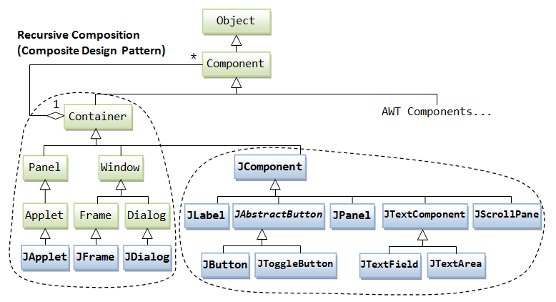

Figure . AWT and Swing elements

## Swing top-level and secondary-level containers

A container is used to hold components. A container can also hold containers because it is a (subclass of) component. Swing containers are divided into top-level and secondary-level containers:

* Top-level containers:
  + JFrame: used for the application's main window (with an icon, a title, minimize/maximize/close buttons, an optional menu-bar, and a content-pane)
  + JDialog: used for secondary pop-up window (with a title, a close button, and a content-pane).
  + JApplet: used for the applet's display-area (content-pane) inside a browser’s window
* Secondary-level containers can be used to group and layout relevant components (most commonly used is JPanel)

## Using JPanel as secondary-level container to organize components

### Create class NumberGrid

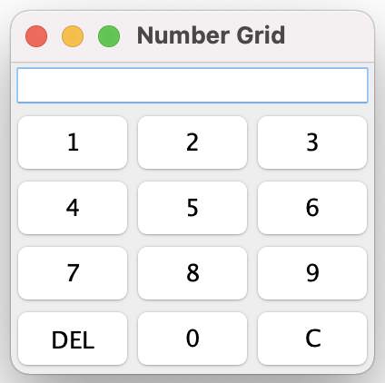

Figure . NumberGrid

This class allows us to input a number digit-by-digit from a number grid into a text field display. We can also delete the latest digit or delete the entire number and start over.

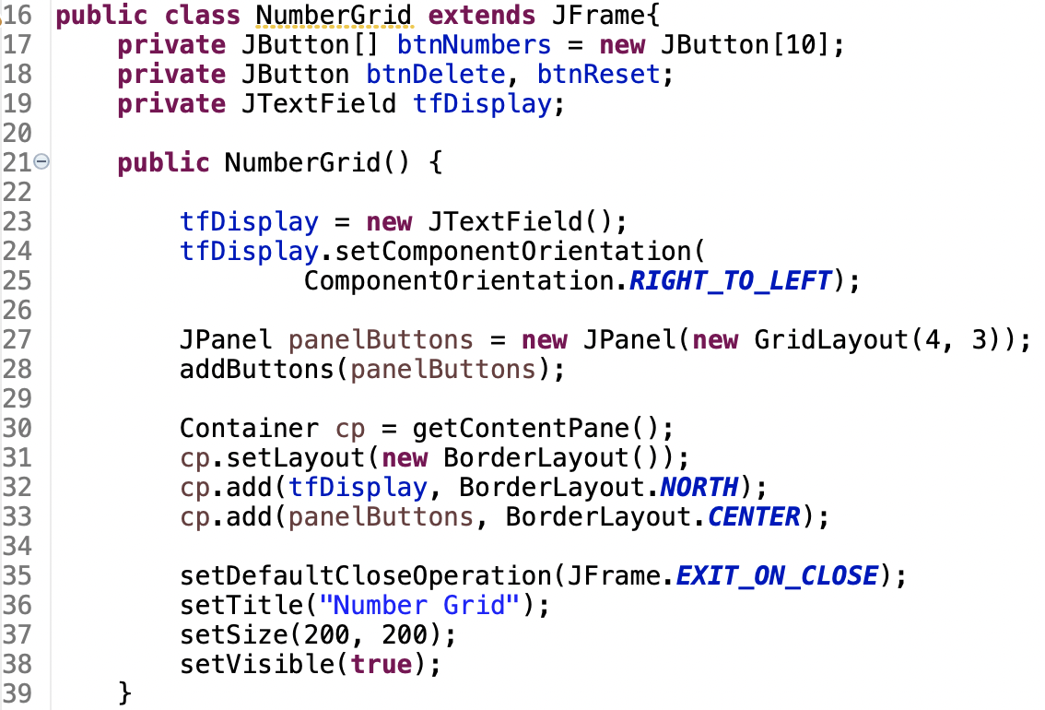

Figure . NumberGrid source code(1)

The class has several attributes:

* The btnNumbers array for the digit buttons
* The btnDelete for the DEL button
* The btnReset for the C button
* The tfDisplay for the top display

In the constructor, we add two components to the content pane of the JFrame:

* A JTextField for the display text field
* A JPanel, which will group all of the buttons and put them in a grid layout

### Adding buttons

We add the buttons to the panelButtons in the addButtons() method:

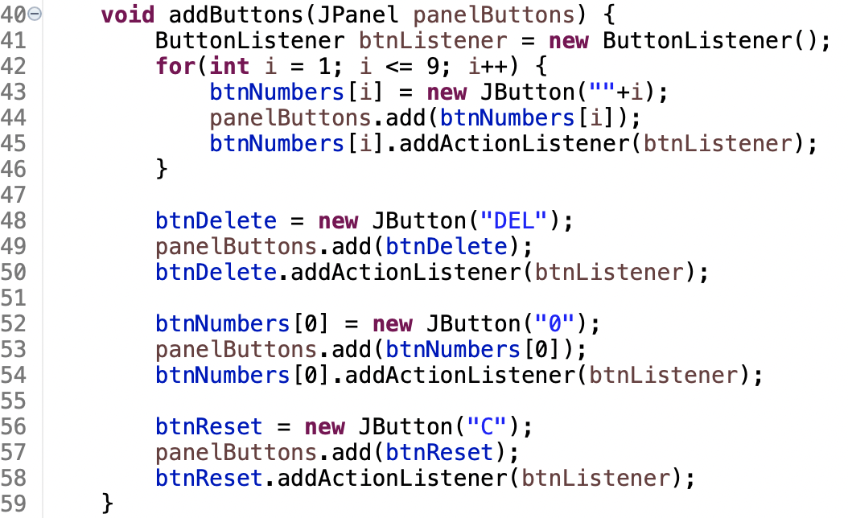

Figure . NumberGrid source code(2)

The buttons share the same listener of the ButtonListener class, which is a named inner class.

### Complete inner class ButtonListener

Your task is to complete the implementation of the ButtonListener class below:

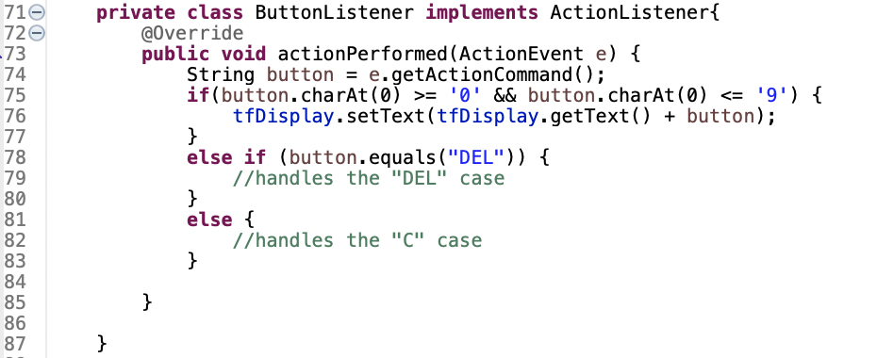

Figure . NumberGrid source code(3)

In the actionPerformed() method, we will handle the button pressed event. Since we have many sources, we need to determine which source is firing the event (which button is pressed) and handle each case accordingly (change the text of the display text field). Here, we have three cases:

* A digit button: a digit is appended to the end
* DEL button: delete the last digit
* C button: clears all digits

The code for the first case is there for reference, you need to implement by yourself the remaining two cases.

# Create a graphical user interface for AIMS with Swing

For the AIMS application, we will implement three screens:

* The “View Store” screen using Swing
* The “View Cart” screen using JavaFX
* The “Update Store” screen using either Swing or JavaFX depending on you

In this exercise, we will make the first screen of the Aims application, the View Store Screen

Put the source code in this exercises in the AimsProject’s “**hust.soict.globalict.aims.screen**” package (for ICT) or the “**hust.soict.dsai.aims.screen**” package (for DS&AI).

## View Store Screen

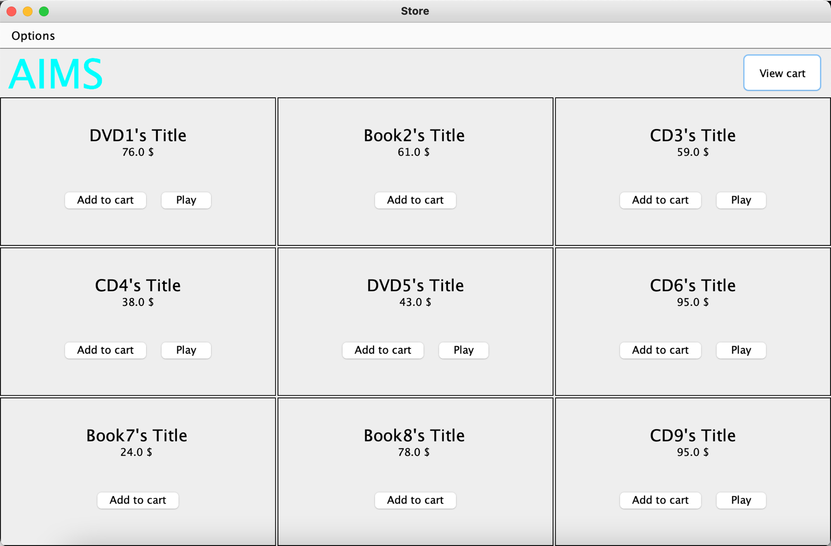

Figure . View Store Screen

For the View Store Screen, we will use the BorderLayout:

In the NORTH component, there will be the menu bar and the header

In the CENTER component, there will be a panel which uses the GridLayout, each cell is an item in the store.

### Create the StoreScreen class

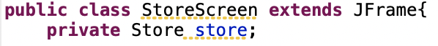

Figure . Declaration of StoreScreen class

This will be our View Store Screen.

Declare one attribute in the StoreScreen class: Store store. This is because we need information on the items in the store to display them

### The NORTH component

Create the method createNorth(), which will create our NORTH component:

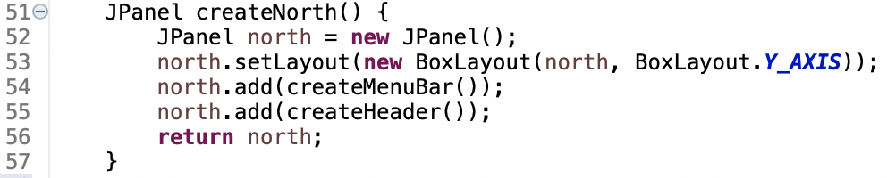

Figure . createNorth() source code

Create the method createMenuBar():

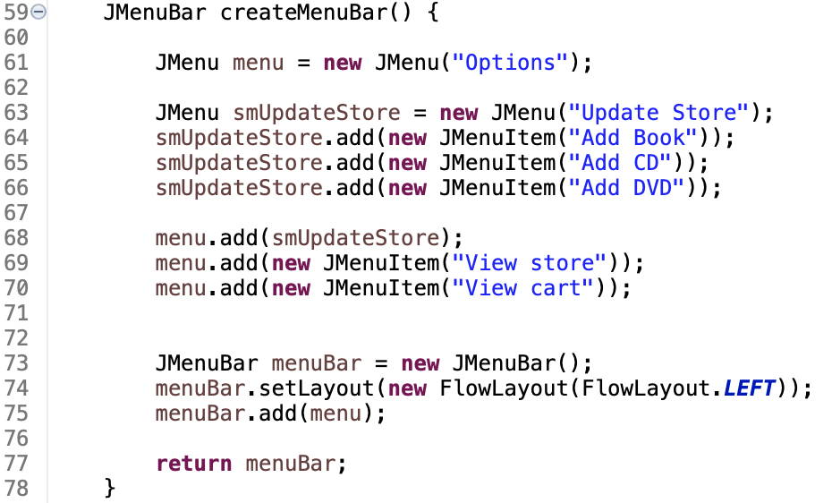

Figure . createMenuBar() source code

The resulting menu bar will look something like this:

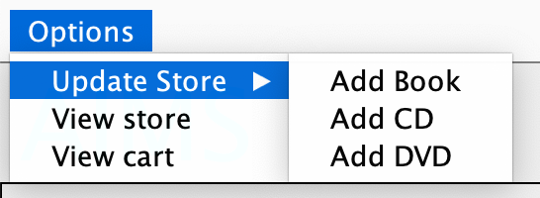

Figure . Resulting menu on menu bar

Create the method createHeader():

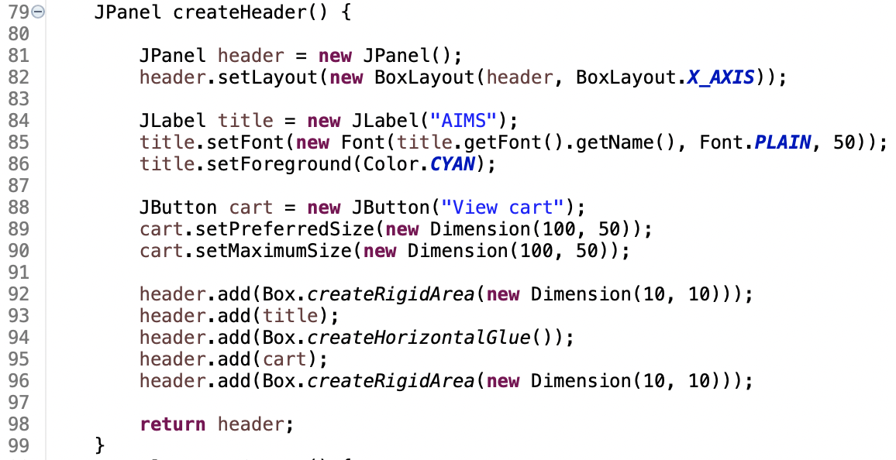

Figure . createHeader() source code

### The CENTER component

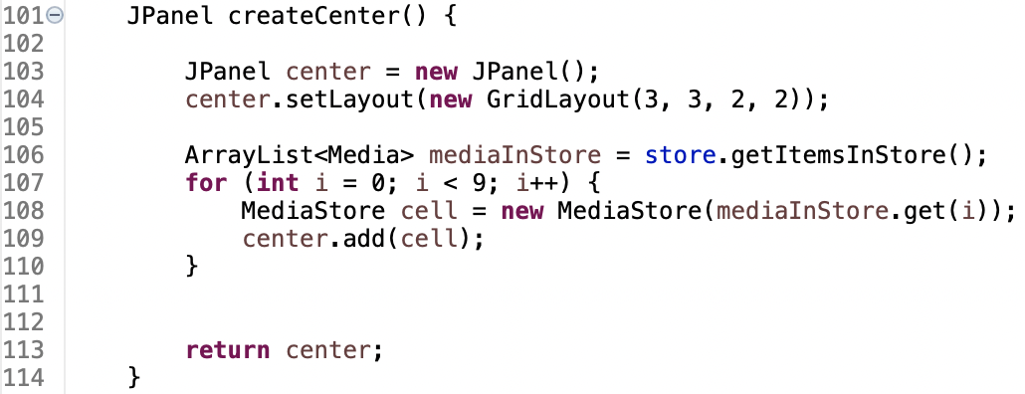

Figure . createCenter() source code

Here, we see that each cell is an object of class MediaStore, which represents the GUI element for a Media in the Store Screen.

### The MediaStore class

Here, since the MediaStore is a GUI element, it extends the JPanel class. It has one attribute: Media media.

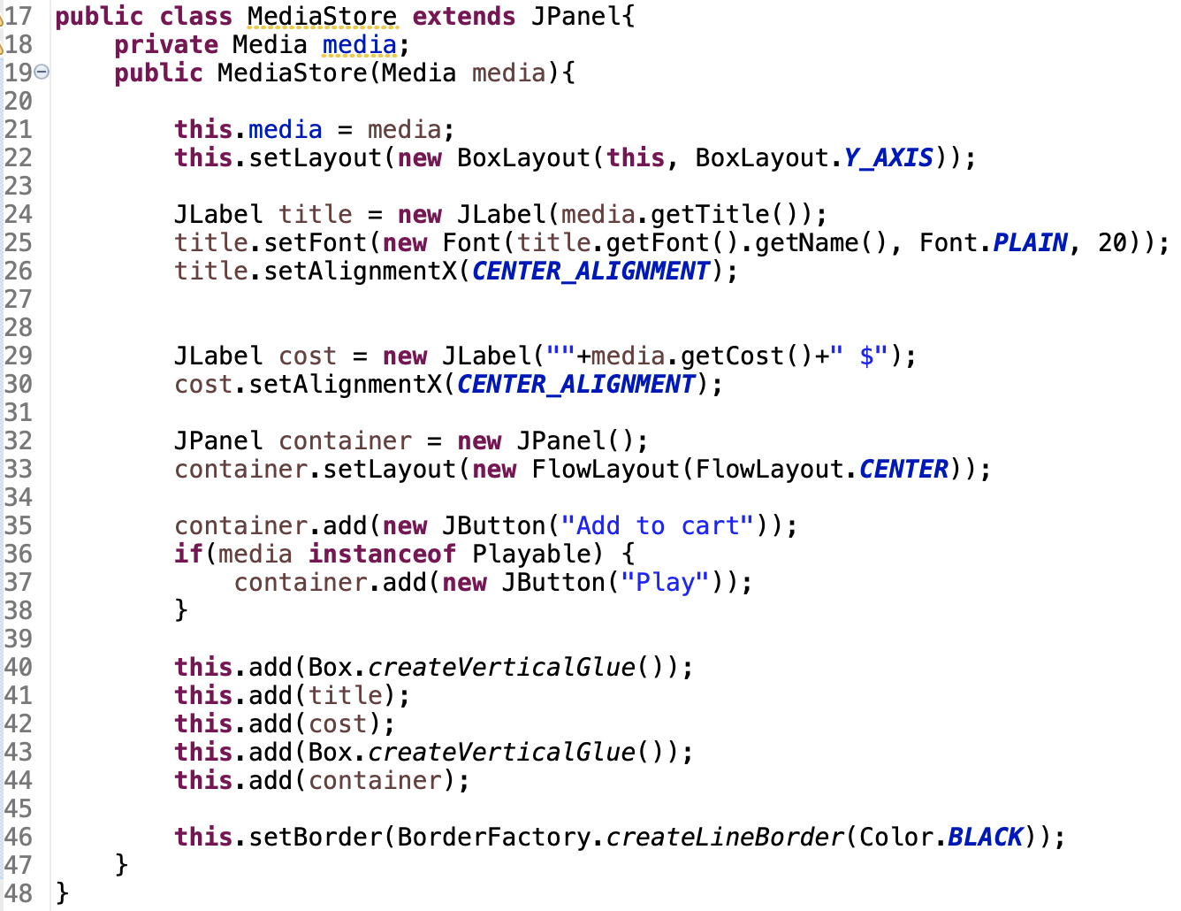

Figure . MediaStore source code

Note how the code checks if the Media implements the Playable interface to create a “Play” button.

### Putting it all together

Finally, we have all the component methods to use in the constructor of StoreScreen:

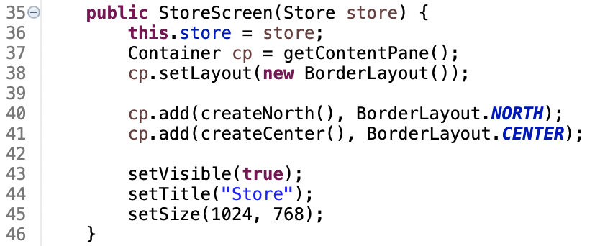

Figure . StoreScreen constructor source code

## Adding more user interaction

We have successfully set up all the components for our store, but they are just static – buttons and menu items don’t respond when being clicked. Now, it’s your task to implement the handling of the event when the user interacts with:

* The buttons on MediaHome:
* When user clicks on the “Play” button, the Media should be played in a dialog window. You can use JDialog here.
* When user clicks on the “Add to cart” button, the Media should be added to the cart.

**Note**: The GUI of the “View cart” & “Update Store” functionality will be implemented in the next exercises. For now, it should suffice to still use the console interface for them.

# JavaFX API

**Note**: For this exercise, you will continue to use the GUIProject, and put all your source code in a package called “**hust.soict.globalict.javafx**” (for ICT) or “**hust.soict.dsai.javafx**” (for DS & AI). ***You might need to add the JavaFX library to this project if you are using JDK version after 1.8***.

In this exercise, we revisit the components of a JavaFX application by implementing a simple Painter app which allows user to draw on a white canvas with their mouse.

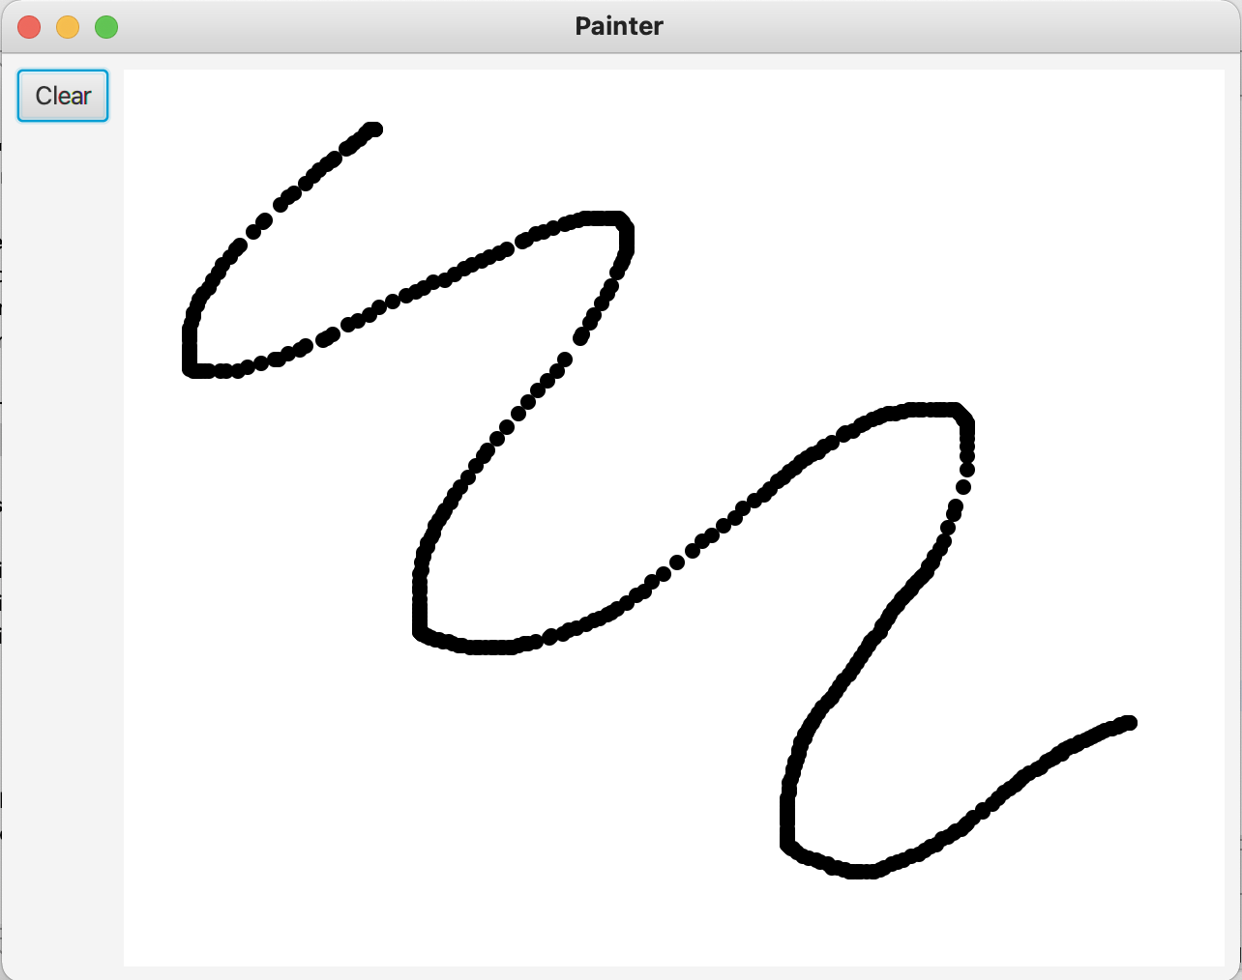

Figure . Painter app

Recall the basic structure of a JavaFX application: It uses the metaphor of a theater to model the graphics application. A stage (defined by the javafx.stage.Stage class) represents the top-level container (window). The individual controls (or components) are contained in a scene (defined by the javafx.scene.Scene class). An application can have more than one scene, but only one of the scenes can be displayed on the stage at any given time. The contents of a scene is represented in a hierarchical scene graph of nodes (defined by javafx.scene.Node).

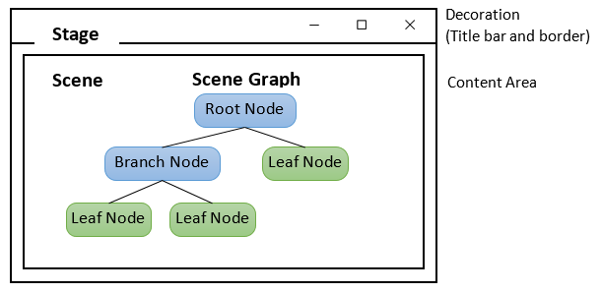

Figure . Structure of JavaFX application

Like any other JavaFX applications, there are 3 steps for creating this Painter app as follows:

* Create the FXML file “Painter.fxml” (we will be using Scene Builder)
* Create the controller class PainterController
* Create the application class Painter

The FXML file lays out the UI components in the scene graph. The controller adds the interactivity to these components by providing even-handling methods. Together, they complete the construction of the scene graph. Finally, the application class creates a scene with the scene graph and add it to the stage.

## Create the FXML file

### Create and open the FXML file in Scene Builder from Eclipse

Right-click on the appropriate package of GUIProject in Project Explorer. Select New > Other… > New FXML Document as in Figure 20.

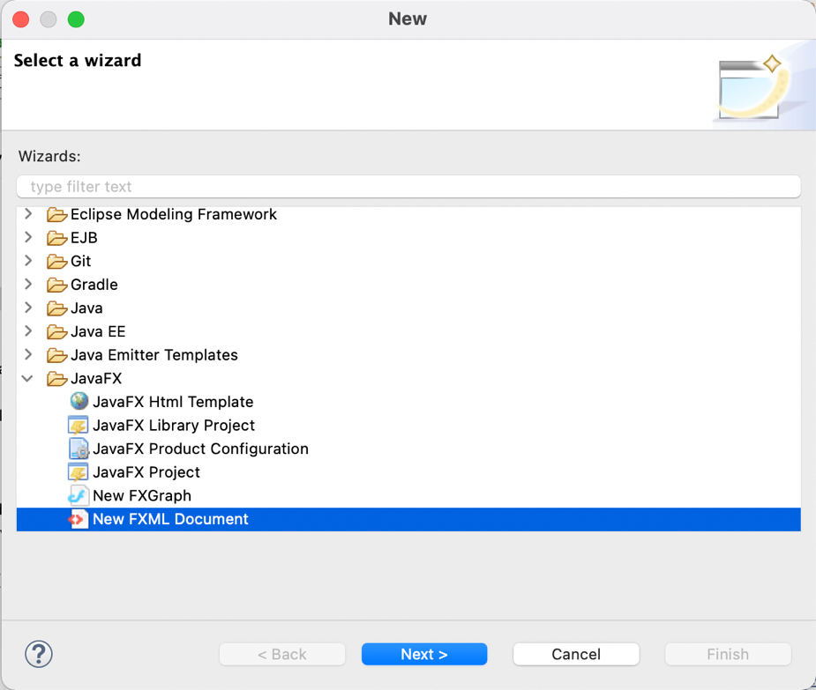

Figure . Create a new FXML in Eclipse(1)

Name the file “Painter” and choose BorderPane as the root element as in Figure 21

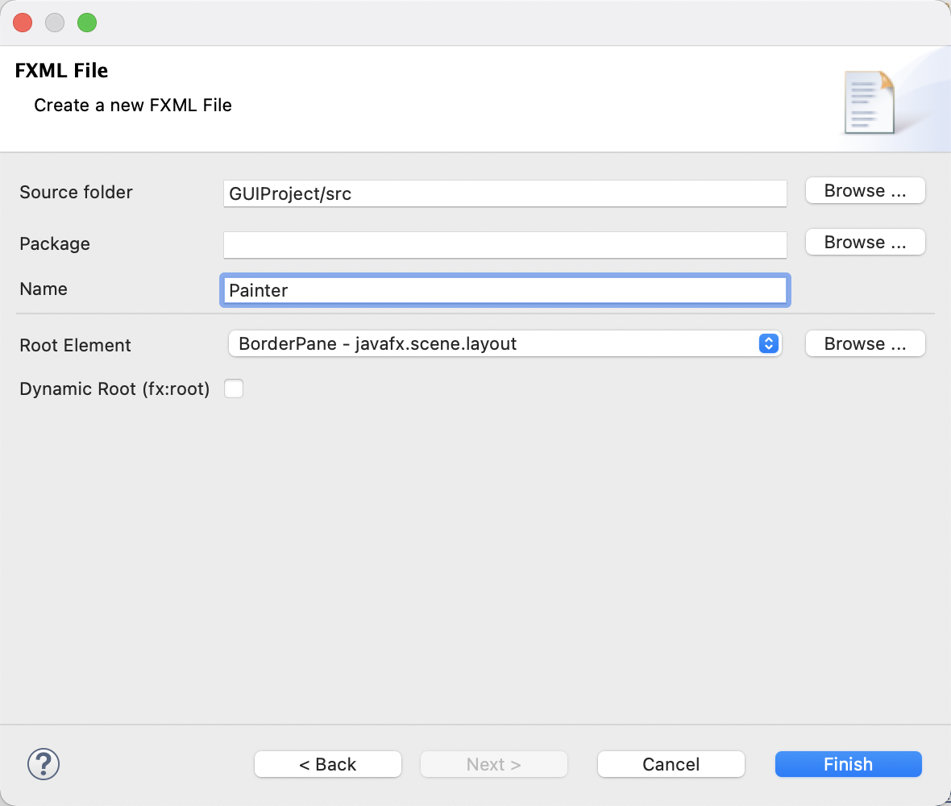

Figure . Create a new FXML in Eclipse(2)

A new file is created. Right-click on it in Project Explorer and select Open with SceneBuilder

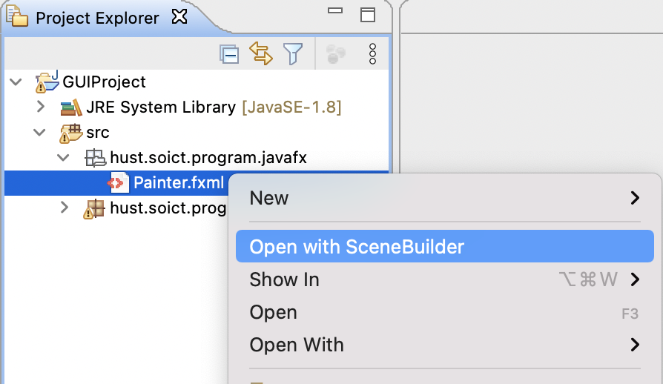

Figure . Open FXML with SceneBuilder from Eclipse

### Building the GUI

Our interface is divided into two sections: A larger section on the right for the user to paint on and a smaller section on the left which acts as a menu of tools and functionalities. For now, the menu only contains one button for the user to clear the board.

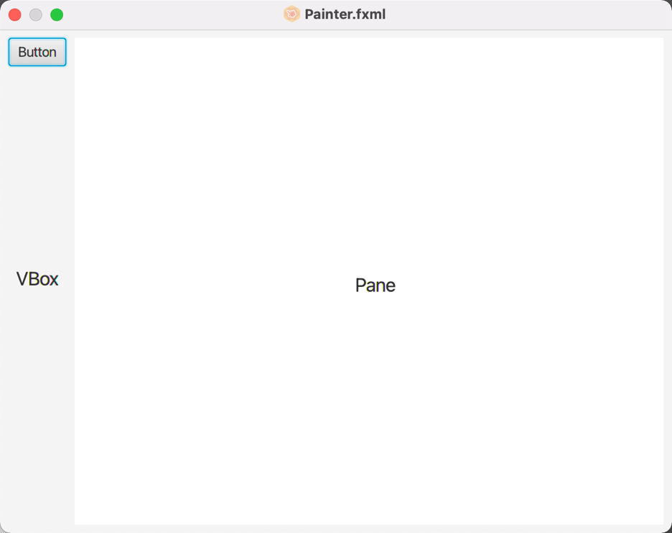

Figure . Target interface

For the right-side section, we use a regular Pane. On the other hand, for the left-side section, since we want to arrange subsequent items below the previous ones vertically, we use a VBox layout.

**Step 1**. Configuring the BorderPane – the root element of the scene

* We set the GridPane’s Pref Width and Pref Height properties to 640 and 480 respectively. Recall that the stage’s size is determined based on the size of the root node in the FXML document
* Set the BorderPane’s Padding property to 8 to inset it from the stage’s edges

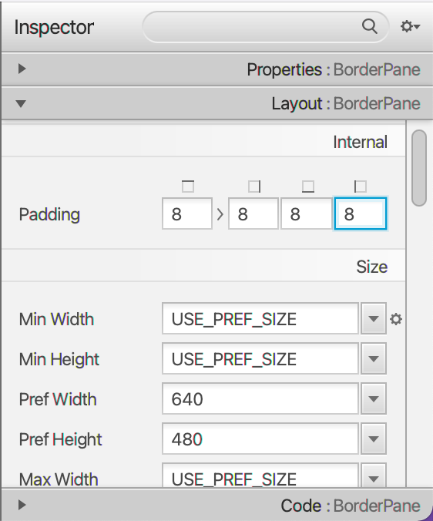

Figure . Configuring the BorderPane

**Step 2**. Adding the VBox

* Drag a VBox from the library on the left hand-side (you can search for VBox) into the BorderPane’s LEFT area.

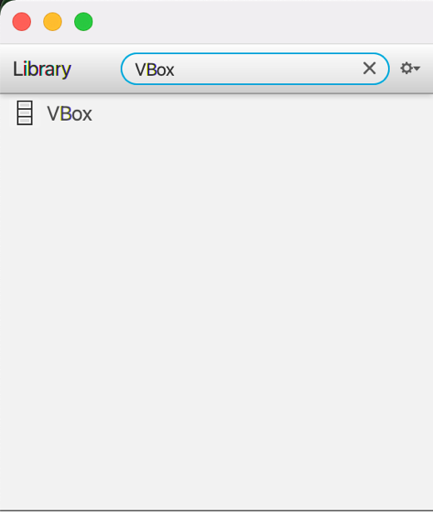

Figure . Get VBox in the Library menu

* Set the Pane’s fx:id to **drawingAreaPane**.
* Set its Spacing property (in the Inspector’s Layout section) to 8 to add some vertical spacing between the controls that will be added to this container (XXX)
* Set its right Margin property to 8 to add some horizontal spacing between the VBox and the Pane be added to this container (XXX)
* Also reset its Pref Width and Pref Height properties to their default values (USE_COMPUTED_SIZE) and set its Max Height property to MAX_VALUE. This will enable the VBox to be as wide as it needs to be to accommodate its child nodes and occupy the full column height (XXX)

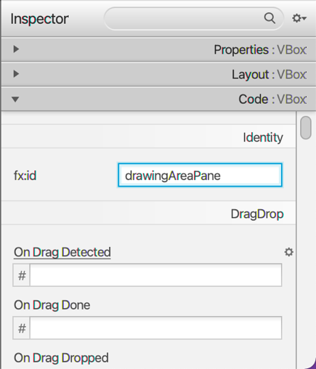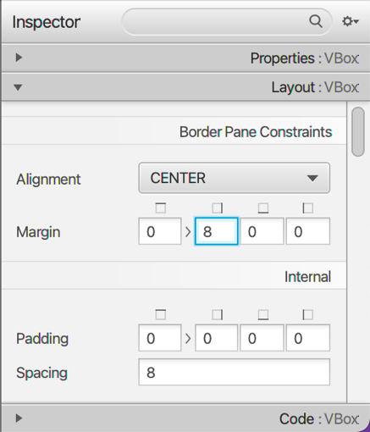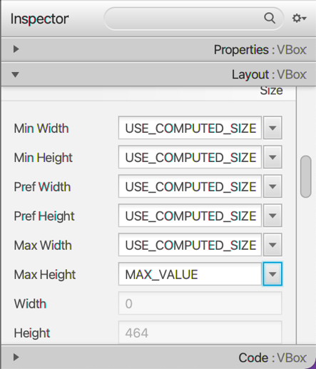

Figure . Configuring the VBox

**Step 3**. Adding the Pane

* Drag a Pane from the library on the left hand-side into the BorderPane’s CENTER area.
* In the JavaFX CSS category of the Inspector window’s Properties section, click the field below Style (which is initially empty) and select -fx-background-color to indicate that you’d like to specify the Pane’s background color. In the field to the right, specify white.
* Specify drawingAreaMouseDragged as the On Mouse Dragged event handler (located under the Mouse heading in the Code section). This method will be implemented in the controller.

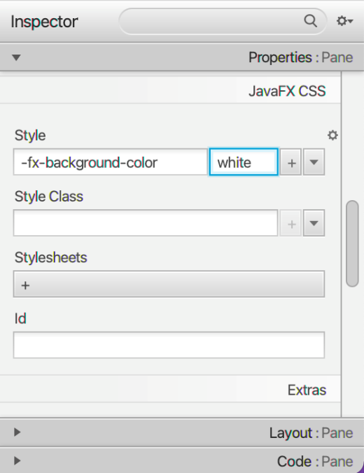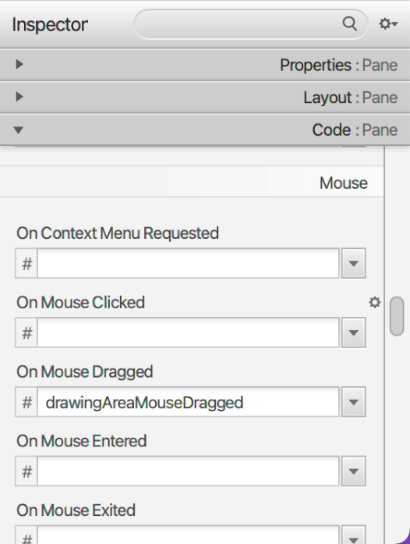

Figure . Configuring the Pane

**Step 4**. Adding the Button

* Drag a Button from the library on the left hand-side into the VBox.
* Change its text to “Clear” and set its Max Width property to MAX_VALUE so that it fills the VBox’s width.
* Specify clearButtonPressed as the On Action event handler. This method will be implemented in the controller.

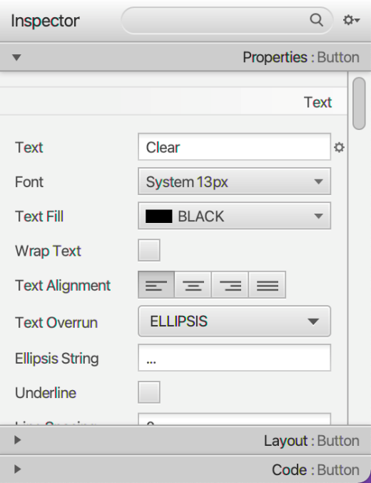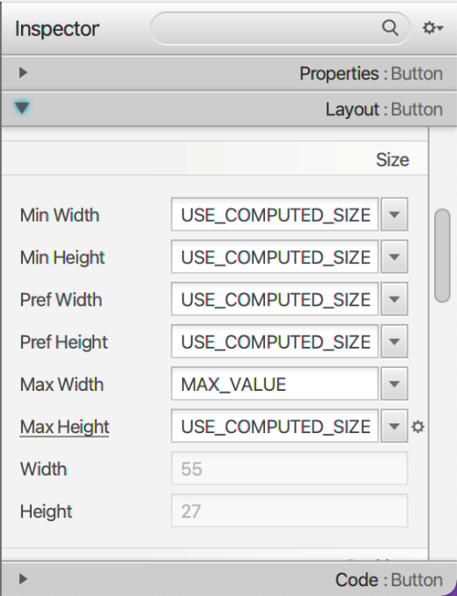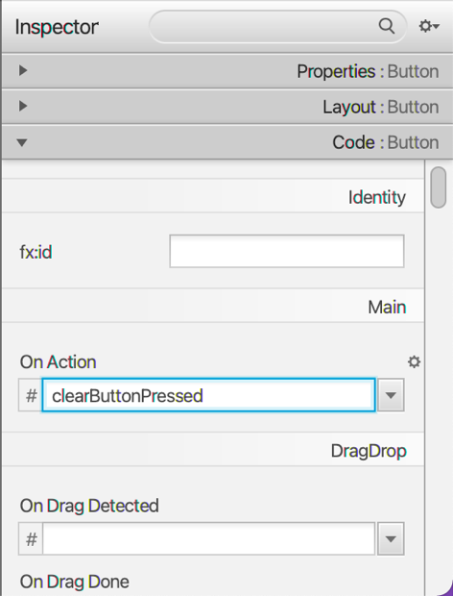

Figure . Configuring the Button

Now that all the elements are set, you can preview them by selecting Preview > Show Preview in Window

## Create the controller class

In the same package as the FXML, create a Java class call PainterController. You can also utilize Scene Builder for coding the controller as follows: Select View > Show Sample Controller Skeleton. A window like in XXX will appear:

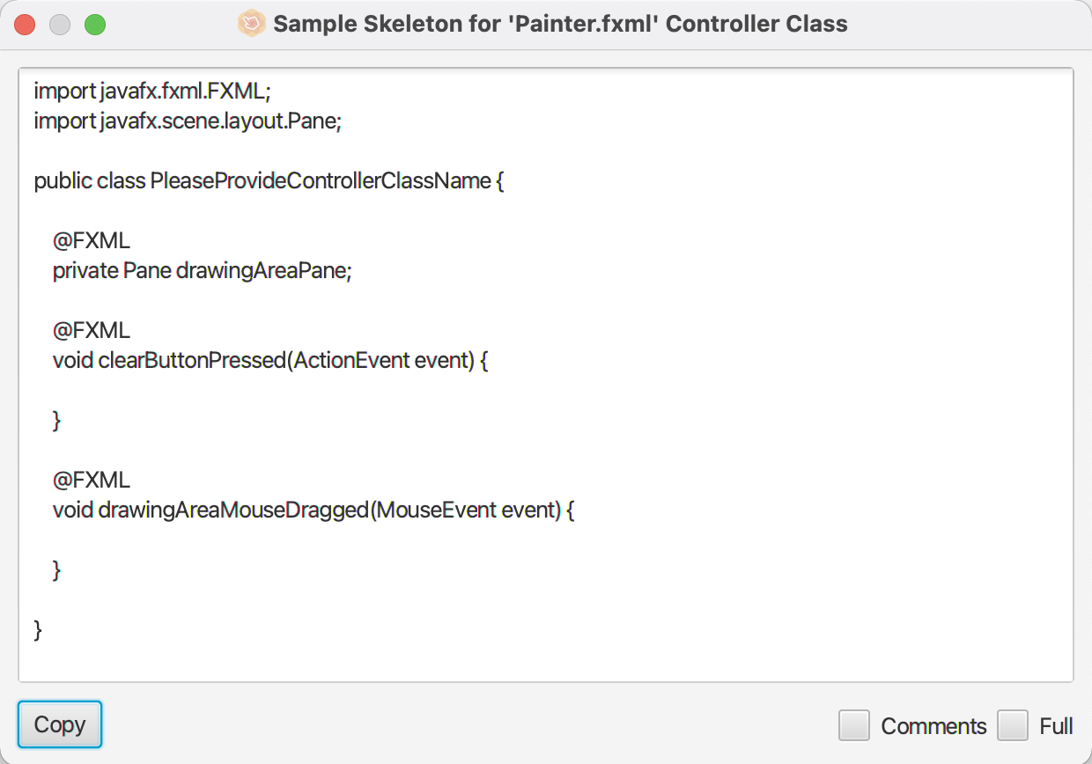

Figure . Auto-generated skeleton code for controller

You can choose to copy the skeleton and paste it in your PainterController.java file. Remember to replace the class name in the skeleton code with your actual class name (PainterController). The results look roughly like this:

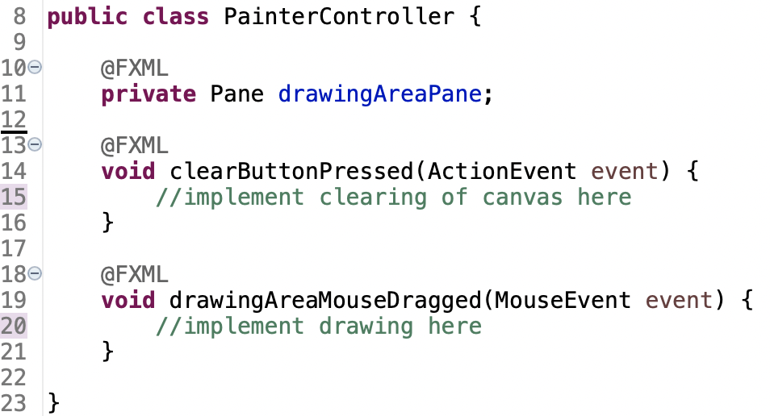

Figure . Skeleton copied into PainterController

Next, we will implement the event-handling functions.

For the drawingAreaMouseDragged() method, we determine the coordinate of the mouse through event.getX() and event.getY(). Then, we add a small Circle (approximating a dot) to the Pane at that same position. We do this by getting the Pane’s children list – which is an ObservableList - and add the UI object into the list.

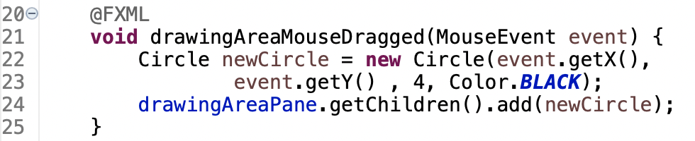

Figure .Source code of drawingAreaMouseDragged()

For the clearButtonPressed() method, we simply need to clear all the Circle objects on the Pane. Again, we have to access the Pane’s children list through Pane.getChildren().

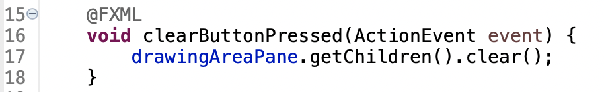

Figure . Source code of clearButtonPressed()

The source code for the controller is complete, however, to ensure that an object of the controller class is created when the app loads the FXML file at runtime, you must specify the controller class’s name in the FXML file using Scene Builder, in the lower right corner under Document menu > Controller.

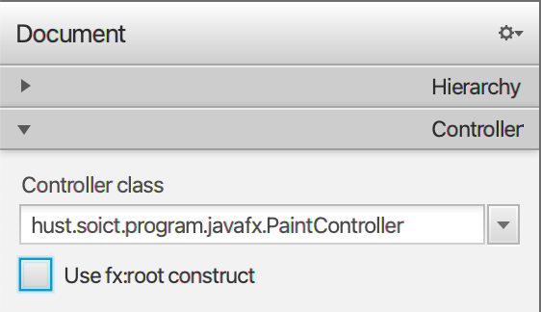

Figure . Specify the controller for the FXML file in Scene Builder

## Create the application

Create a class named Painter in the same package as the FXML and the controller class. The source code is provided below:

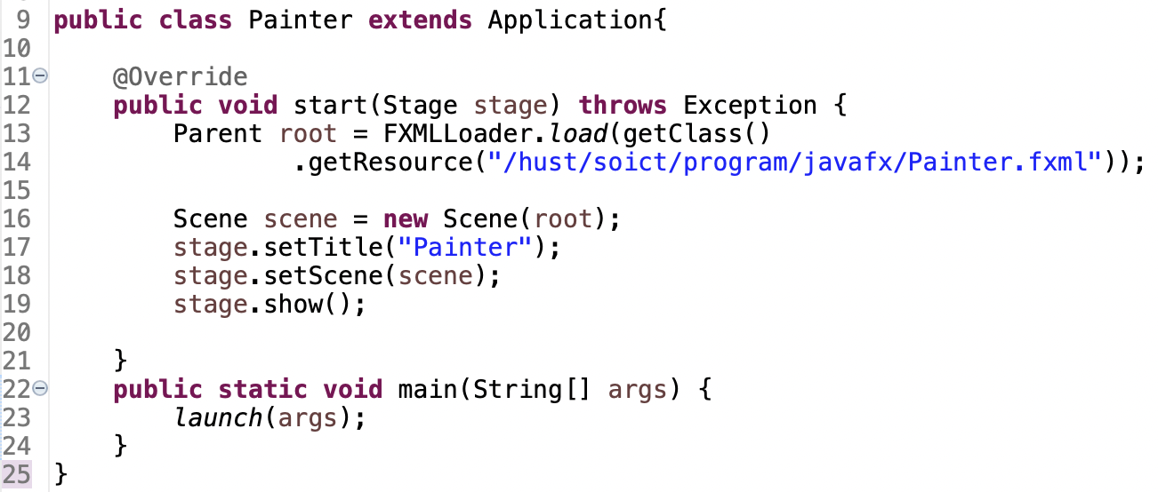

Figure . Painter source code

Explanation of the code:

* All JavaFX application must extend the Application class.
* main() method:

In the main method, the launch method is called to launch the application. Whenever an application is launched, the JavaFX runtime does the following, in order:

* + Constructs an instance of the specified Application class
  + Calls the init method
  + Calls the start method
  + Waits for the application to finish
  + Calls the stop method

Note that the start method is abstract and must be overridden. The init and stop methods have concrete implementations that do nothing.

* start() method:

Here, in the start method a simple window is set up by loading the FXML into the root note. From that root node, a Scene is created and set on the Stage.

## Practice exercise

Your task now is to add the Eraser feature. The new interface of the app including the new eraser functionality should be like this:

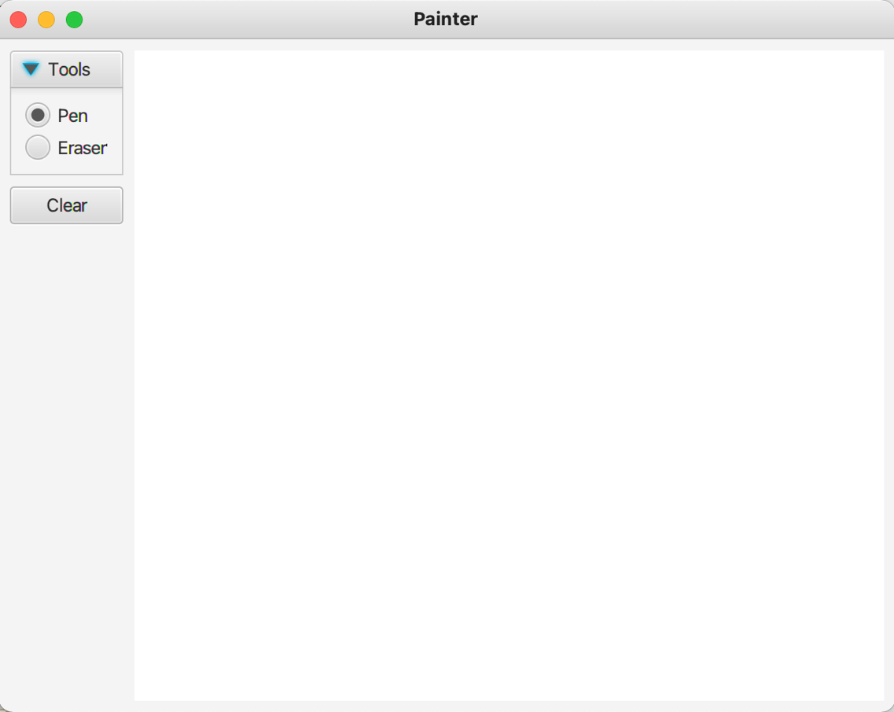

Figure . Painter with Eraser

**Hint**:

* For the interface design: use TitledPane and RadioButton. Using Scene Builder, set the Toggle Group properties of the RadioButtons as identical, so only one of them can be selected at a time.
* For the implementation of Eraser: One approach is to implement an eraser just like a pen above, but use white ink color (canvas color) instead.

# Setting up the View Cart Screen with ScreenBuilder

**Note**: For the next 7 exercises for the AimsProject, put the source code under the package “**hust.soict.globalict.aims.screen**” package (for ICT) or the “**hust.soict.dsai.aims.screen**” package (for DS&AI).

We will design a View Cart Screen that looks roughly as below:

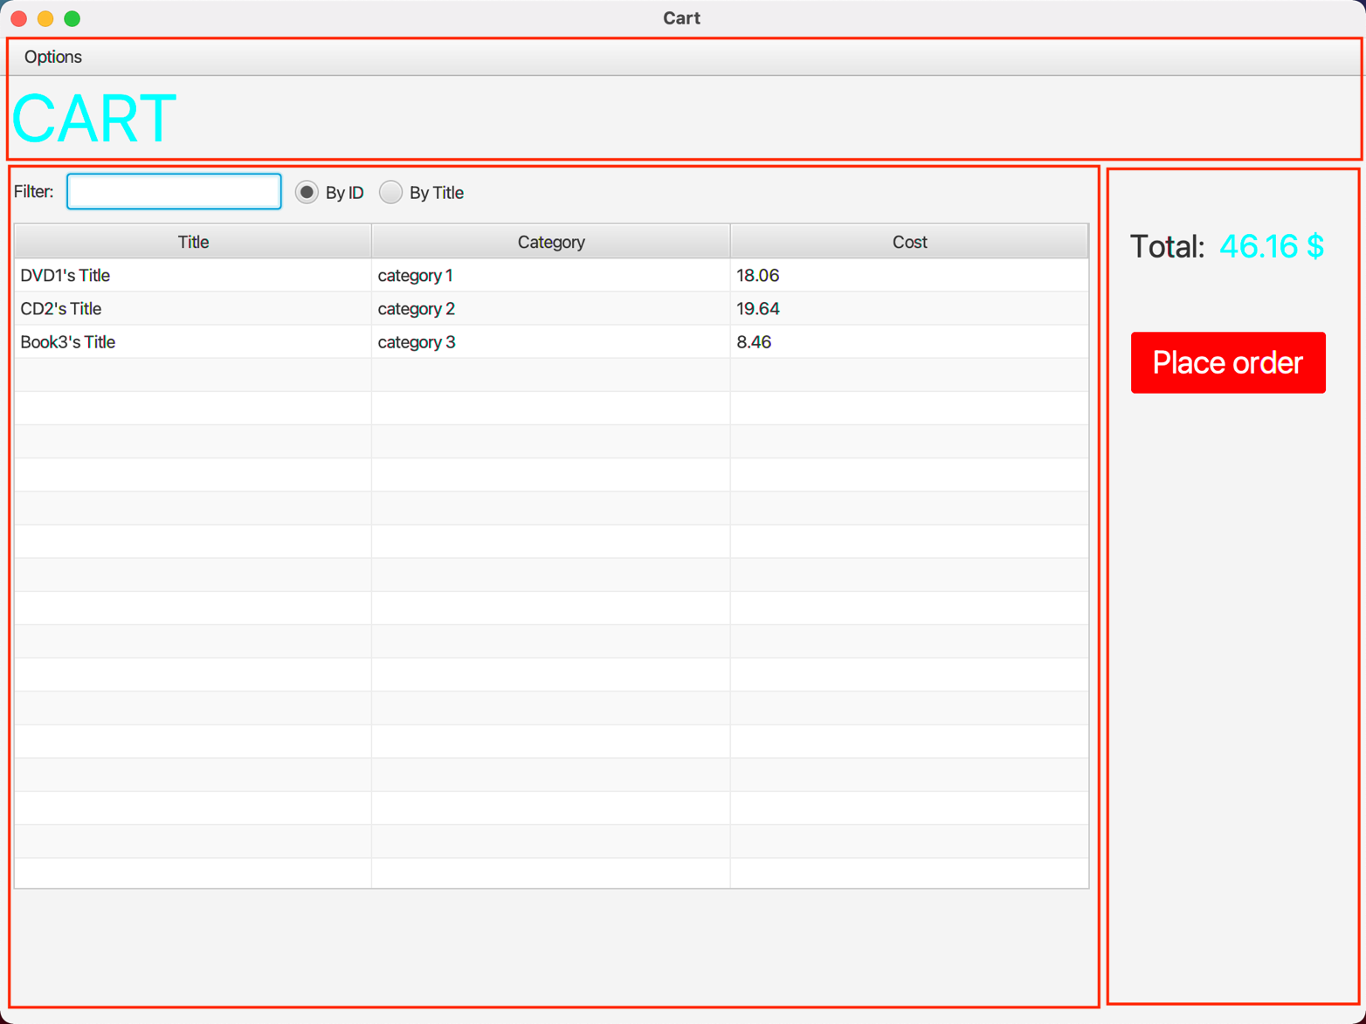

Figure . View Cart Screen

Like the previous exercise, we start by creating an FXML file named “**cart.fxml**” with BorderPane being the root node. This layout is the most appropriate for our screen, which clearly has three distinct areas (bounded in red borders) corresponding to TOP, CENTER and RIGHT areas of BorderPane.

## Setting up the BorderPane

* Layout: Pref Width: 1024
* Layout: Pref Height: 768

## Setting up the TOP area

Since the TOP area contains only the MenuBar on top of the header, we will use the Vbox layout.

Step 1. Drag a VBox into the BorderPane’s NORTH area.

* Layout: Pref HEIGHT: USE_COMPUTED_SIZE

Step 2. Add a MenuBar into the VBox

* Set up the MenuBar as in Figure 37:

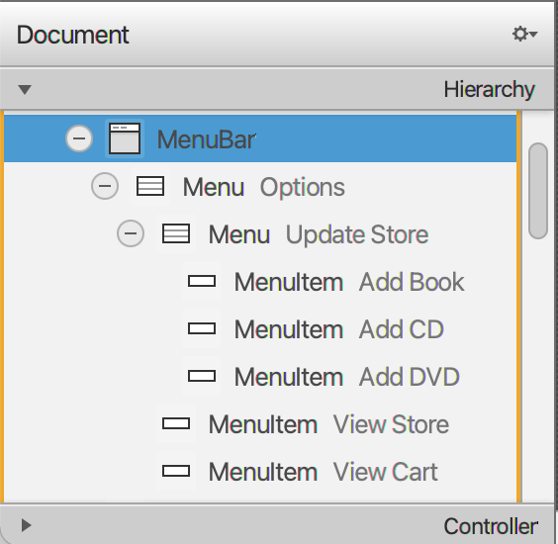

Figure . Set up of the MenuBar

Step 3. Add a label into the VBox

* Properties: Text: CART
* Properties: Font: 50px
* Properties: Text Fill: #00ffff (AQUA)
* Layout: Padding: 10 left

## Setting up the CENTER area

Similar to the TOP area, we use the VBox layout for the CENTER areas to arrange components vertically. Inside the Vbox, we use a HBox to arrange the top row of components horizontally. We also use a TableView to display data in a tabular form.

Step 1. Drag a VBox into the CENTER area

* Layout: Padding: 10 left

Step 2. Add a HBox into the VBox

* Properties: Alignment: CENTER_LEFT
* Layout: Padding: 10 top & bottom
* Layout: Spacing: 10
* Layout: Pref Height: USE_COMPUTED_SIZE

Step 2.1. Add a Label into the HBox

* Properties: Text: Filter:

Step 2.2. Add a TextField into the HBox

Step 2.3. Add the first RadioButtons into the HBox

* Properties: Text: By ID
* Properties: Selected: ü
* Properties: Toggle Group: filterCategory

Step 2.4. Add the second RadioButtons into the HBox

* Properties: Text: By Title
* Properties: Toggle Group: filterCategory

Step 3. Add a TableView into the VBox

* 3 TableColumns: Properties: Text: Title, Category & Cost.
* Column Resize Policy: constrained-resize
* Layout: Pref Width: USE_COMPUTED_SIZE
* Layout: Pref Height: USE_COMPUTED_SIZE

Step 4. Add a ButtonBar into the VBox

* 2 Buttons: Play, Remove

## Setting up the RIGHT area

Step 1. Drag a VBox into the RIGHT area

* Properties: Alignment: TOP_CENTER
* Layout: Pref Width: USE_COMPUTED_SIZE
* Layout: Padding: 50 top

Step 2. Add an HBox into the VBox

* Properties: Alignment: CENTER
* Layout: Pref Width: USE_COMPUTED_SIZE
* Layout: Pref Height: USE_COMPUTED_SIZE

Step 3. Add a Label into the HBox

* Properties: Text: Total:
* Properties: Font: 24px
* Layout: Spacing: 10

Step 4. Add another Label into the HBox

* Properties: Text: 0 $
* Properties: Font: 24px
* Properties: Text Fill: #00ffff (AQUA)

Step 5. Add a Button into the VBox

* Properties: Text: Place Order
* Properties: Font: 24px
* Properties: Text Fill: #ffffff (WHITE)
* Properties: Style: -fx-background-color: red

# Integrating JavaFX into Swing application – The **JFXPanel** class

Previously, we have developed the Aims application using a different GUI library - Swing. Now, we need to find a way to integrate our JavaFX code into this existing Swing application. This exercise is a demonstration on how to do this task.

So far, we have only used the JavaFX Library to create JavaFX applications. In these applications, we use the load() method of the FXMLLoader class to load an FXML file and create a controller object for it and return a resulting Node object. Normally, with a JavaFX application, this Node would be put on a Scene and the Scene will be shown on a Stage. However, we can elevate this loading mechanism and embed the Node instead in a JFXPanel, which can be used in a JFrame of a Swing application.

Here is how we will implement this:

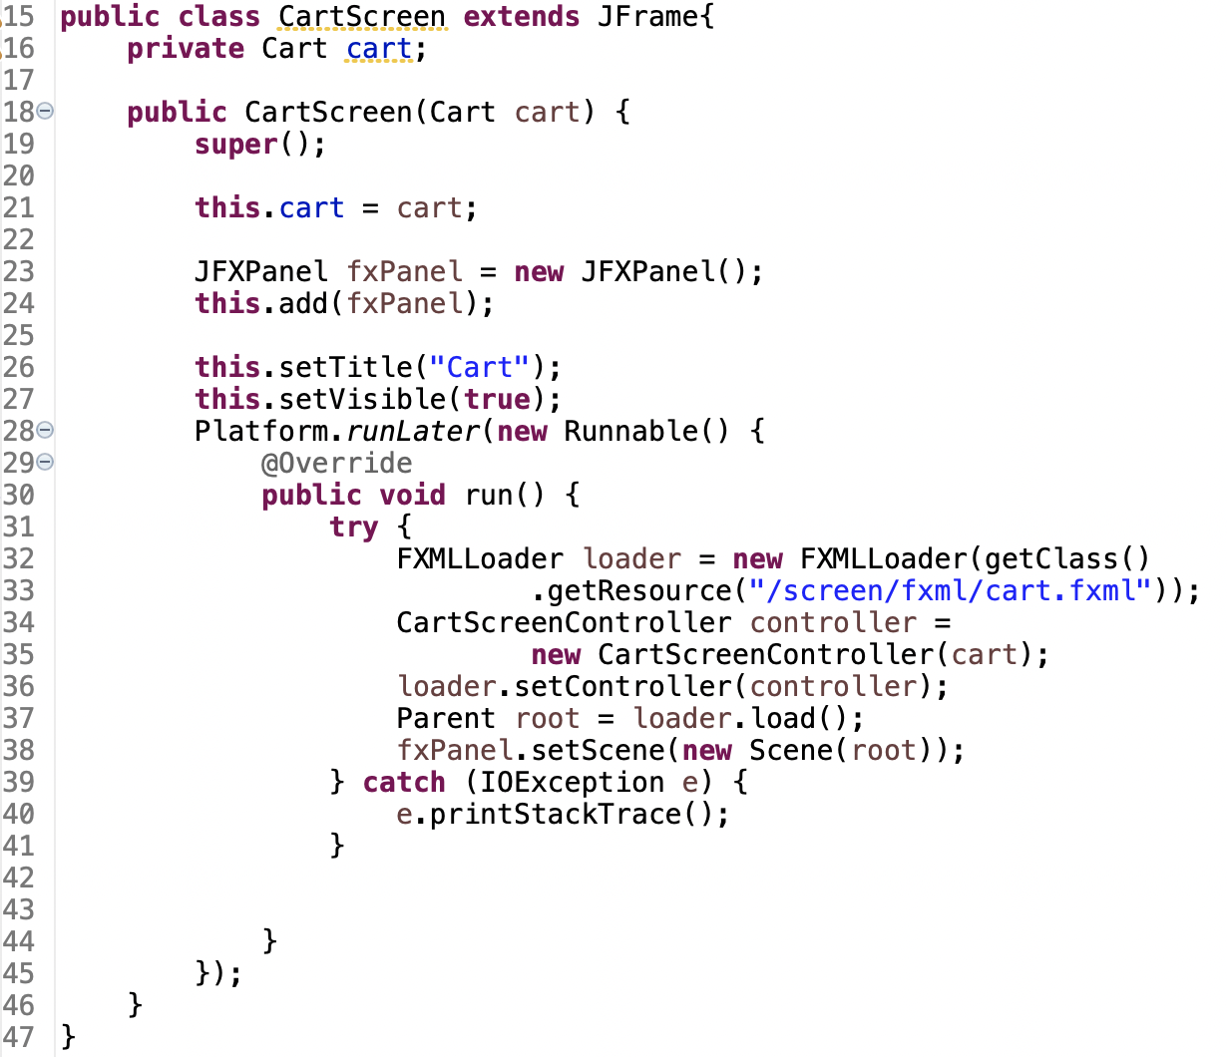

Figure . Source code for CartScreen

We create a CartScreen class that extends the JFrame, just like the StoreScreen class. Inside its constructor, we do the following steps:

* In line 23 – 24, we set up a JFXPanel in our JFrame.
* In line 32 – 37, we load the root Node from the FXML file and create its controller object (we will come to the actual implementation of the controller in the next section).
* In line 38, we create a new Scene with the root Node and add the Scene to the JFXPanel.

# View the items in cart – JavaFX’s data-driven UI

The TableView we created in the previous exercise is currently empty, we need to fill it with data of media items in our cart. We will do so in our controller class.

In order to manipulate our TableView data programmatically in the controller, we need references to the TableView’s columns and itself. A convenient way to do this is using Scene Builder. Open the FXML file “**cart.fxml**” earlier and select the TableView element. Set its fx:id property to **tblMedia**. Similary, set the fx:id property for the columns:

* The Title column: **colMediaTitle**
* The Category column: **colMediacategory**
* The Cost column: **colMediaCost**

Create the class CartScreenController as follows:

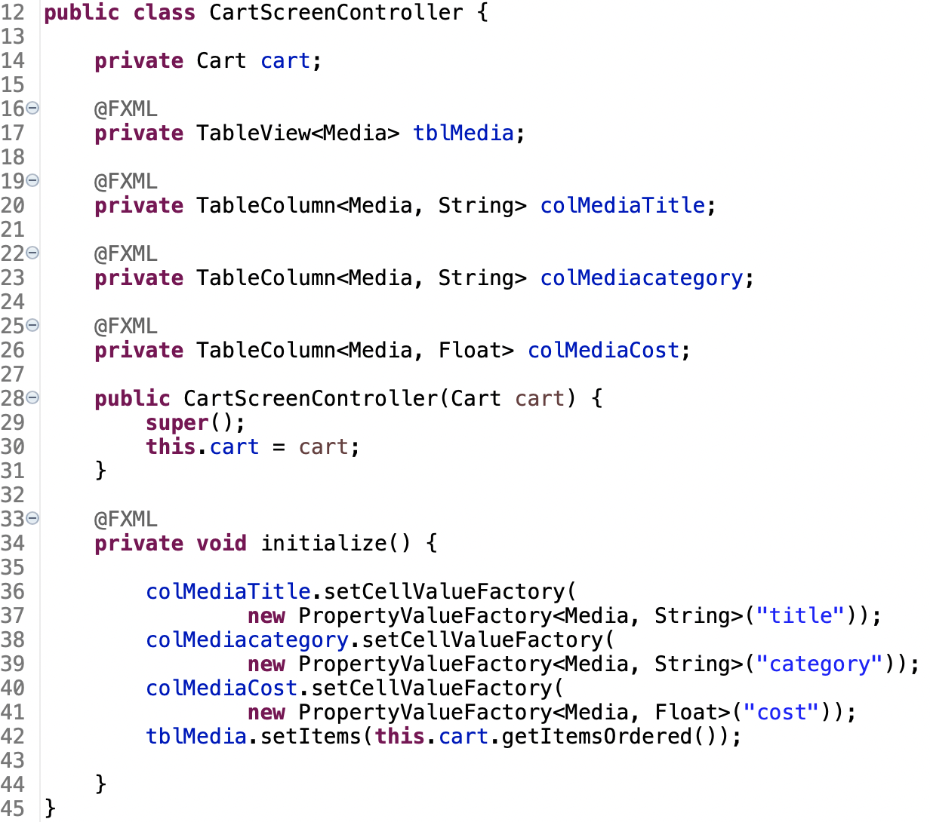

Figure . Source code for CartScreenController

Recall earlier in the CartScreen constructor method, the constructor for CartScreenController is invoked, then the load() method of the FXMLLoader. In the load() method, any @FXML annotated fields are populated, then initialize() is called. That means we use can use the initialize() method to perform any post-processing on the content of the JFrame after it is loaded from FXML and before it is shown.

In line 42, we set the cart’s list of items to the items of the TableView. Note that this will initially cause an error, because we cannot set a regular List as the items of a TableView. Instead, we have to use an ObservableList, so that any change on the data can be observed and reflected by the TableView. Please open the source code of Cart and change the itemsOrdered from List<Media> to ObservableList<Media>

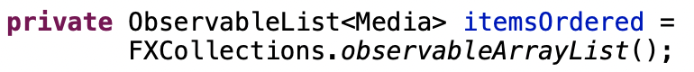

Figure . New itemsOrdered

After setting the items of the TableView, the data still isn’t showing up in the TableView yet, because we still have to set up the way the columns can retrieve data. This is done by setting the columns’ cellValueFactory.

In line 36 – 41, we set the columns’ cellValueFactory using the class PropertyValueFactory<S, T> (Read the Javadocs for more details). This class is a callback that will take in a String <property> and look for the method get<property>() in the Source S class. If a method matching this pattern exists, the value returned from this method is returned to the TableCell.

You can now test the View Cart Screen with some media in your cart, the results will look roughly like in Figure 41

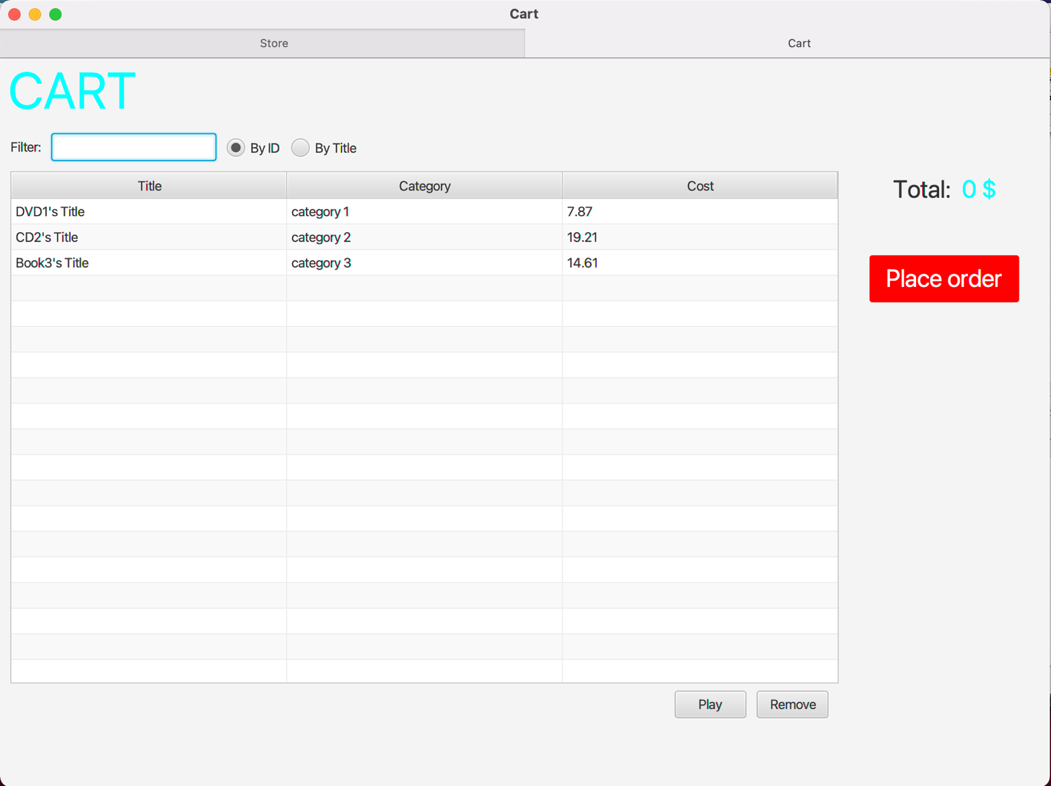

Figure . Test displaying TableView data

# Updating buttons based on selected item in **TableView** – **ChangeListener**

We will now implement a button bar that changes buttons based on the Media currently selected in the TableView. To do this, again, we need reference to the two buttons in the controller class. Similar to the above, we start by adding the fx:id property for the components in SceneBuilder:

* The “Play” Button: **btnPlay**
* The “Remove” Button: **btnRemove**

Make sure to create the corresponding attributes in CartScreenController. You can copy from the Scene Builder’s Controller Skeleton with View > Show Sample Controller Skeleton.

First of all, the buttons only appear when a certain Media object is being selected, that means we have to modify the initialize() method to make them invisible at first (line 73 – 74 in Figure 42)

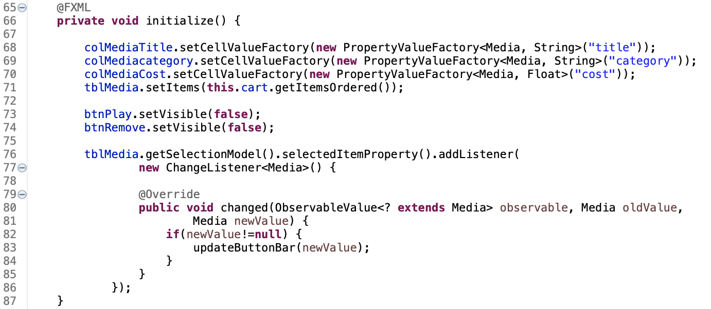

Figure . Modified initialize() method

Put some code at the end of the initialize() method to add a ChangeListener to the TableView’s selectedItem property (line 76 – 86 in Figure 42). Here, we create an anonymous inner class for the ChangeListener. All ChangeListeners must implement the changed() method. Whenever a selected item in the TableView is changed, the method changed() is called. Here, we check to make sure the newValue is not null (the user didn’t just unselect) and call the updateButtonBar() method (Figure 43)

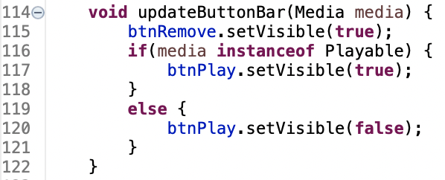

Figure . Source code of updateButtonBar()

# Deleting a media

Next, we will implement the event-handling for the “Remove” button. Please add a method name to the onAction property of the button in Scene Builder. You can refer to the event-handling code as below (change the method name to match the one used by your FXML file):

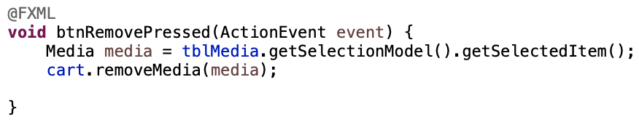

Figure . Handle remove media

Note that we don’t need to invoke an update for the TableView because the it can already observe the changes though the ObservableList and update its display.

# Filter items in cart – **FilteredList**

This exercise is optional (full credit can still be given for this lab without doing this exercise), but you can do it for extra credit.

We will implement a filter that is re-applied every time the user makes a change in the filter text field. To do this, again, we need references to the text field where the user inputs the filter string, and the two radio buttons (to determine what criteria is being used to filter).

Similar to the above, please add the fx:id property for the components in SceneBuilder and create three corresponding attributes in the controller:

* The TextField: **tfFilter**
* The RadioButton “By ID”: **radioBtnFilterId**
* The RadioButton “By Title”: **radioBtnFilterTitle**

At the end of the initialize() method, put some code to add a ChangeListener to the TextField’s text property (illustrated in Figure 45):

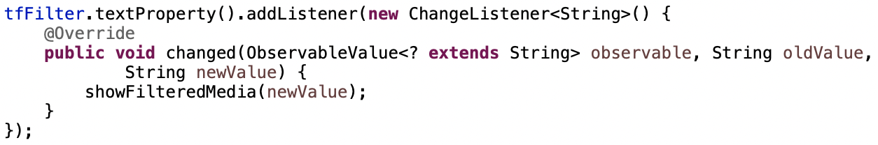

Figure . Adding ChangListener for tfFilter in initialize()

Please implement by yourself the showFilteredMedia() method. **Hint**: You might need to change the source code in previous exercises. Wrap the ObservableList in a FilteredList and set a new Predicate for the FilteredList each time you need to apply a new filter.

# Complete the Aims GUI application

Complete the remaining UI of Aims to make a functioning GUI application

* Cart Screen:
  + “Place order” Button
  + “Play” Button
  + The total cost Label - should updated along with changes in the current cart (add/remove).
  + MenuBar
* Store Screen:
  + “Add to cart” Button
* Update Store Screen:
  + When user clicks on one of the items of the “Update Store” menu on the menu bar (such as “Add Book”, “Add CD”, or “Add DVD”), the application should switch to an appropriate new screen for the user to add the new item. This screen should have the same menu bar as the View Store Screen, so the user can go back to view the store
  + You can choose to use either Swing or JavaFX to implement this
  + For simplicity:
    - you only need to do the “Add item to store” screen, the “Remove item from store” is omitted. As shown above, there is no option of “Remove item from store” in the “Update store” menu.
    - In the “Add item to store” Screen, you don’t need to do data type validation yet.
  + Suggestion: You will need to create more screens for this task. Make other modifications to the source code above as needed. You should create 3 classes AddDigitalVideoDiscToStoreScreen, AddCompactDiscToStoreScreen, and AddBookToStoreScreen, which will take the necessary inputs from user. Since these GUI classes all share part of their interface, if possible, you can apply Inheritance here and create a parent AddItemToStoreScreen class and let the above three class inherit from it
* Other features such as: Remove media from store, search media in store, sort media in cart, lucky item, … are optional, you don’t have to implement them in the GUI. You can still do them for extra credit.

# Check all the previous source codes to catch/handle/delegate runtime exceptions

*Review all methods, classes in AimsProject, catch/handle or delegate all exceptions if necessary.* The exception delegation mechanism is especially helpful for constructors so that no object is created if there is any violation of the requirement/constraints.

Hint: In Aims Project, we can apply exception handling to *validate data constraints* such as non-negative price, to *validate policies* like the restriction of the number of orders, and to handle *unexpected* *interactions*, e.g., user try to remove an author while the author is not listed.

For example, the following piece of code illustrates how to control the number of items in the cart with exception.

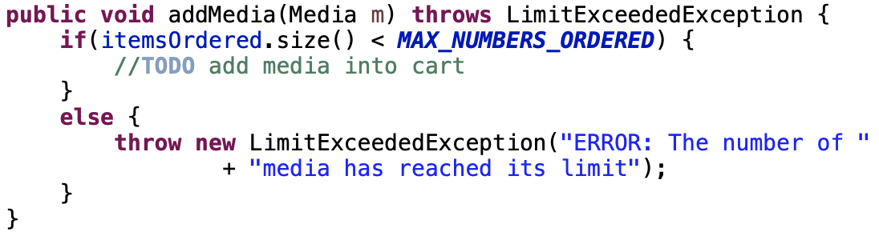

Figure . Sample exception handling code

# Create a class which inherits from **Exception**

The **PlayerException** class represents an exception that will be thrown when an exceptional condition occurs during the playing of a media in your **AimsProject**.

## Create new class named **PlayerException**

- Enter the following specifications in the New Java Class dialog:

* Name: **PlayerException**
* Package: **hust.soict.[globalict||dsai].aims.exception**
* Access Modifier: **public**
* Superclass: **java.lang.Exception**
* Constructor from Superclass: checked
* **public static void main(String [] args):** do not check
* All other boxes: do not check

- Finish

## Raise the **PlayerException** in the **play()** method

- Update **play()** method in **DigitalVideoDisc** and **Track**

* For each of **DigitalVideoDisc** and **Track**, update the **play()** method to first check the object's length using **getLength()** method. If the length of the **Media** is less than or equal to zero, the **Media** object cannot be played.
* At this point, you should output an error message using **System.err.println()** method and the **PlayerException** should be raised.

- The example of codes and results for the **play**() of **DigitalVideoDisc** are illustrated in the following figures.



Figure . Sample code for method play() of DigitalVideoDisc

**- Save your changes and make the same with the play() method of Track.**

## Update **play()** in the **Playable** interface

- Change the method signature for the **Playable** interface's **play()** method to include the throws **PlayerException** keywords.

## Update **play()** in **CompactDisc**

- The **play**() method in the **CompactDisc** is more interesting because not only it is possible for the **CompactDisc** to have an invalid **length** of 0 or less, but it is also possible that as it iterates through the tracks to play each one, there may have a track of length 0 or less

- First update the **play**() method in **CompactDisc** class to check the length using **getLength**() method as you did with **DigitalVideoDisc**

- Raise the **PlayerException**. Be sure to change the method signature to include **throws** **PlayerException** keywords.

- Update the **play()** method to catch a **PlayerException** raised by each **Track** using block **try-catch.**

The code example is shown as follows.



Figure . Sample code for method play() of CompactDisc

- You should modify the above source code so that if any track in a **CD** can’t play, it throws a **PlayerException** exception.

# Update the **Aims** class

- The **Aims** class must be updated to handle any exceptions generated when the **play()** methods are called. What happens when you don’t update for them to catch?

- Try to use **try-catch** block when you call the **play()** method of **Media's** objects.

With all these steps, you have practiced with User-defined Exception (**PlayerException**), **try**-**catch** block and also **throw**. The **try-catch** block is used in the main method of class **Aims.java** and in the **play()** method of the **CompactDisc.java**. Print all information of the exception object, e.g. **getMessage()**, **toString()**, **printStackTrace()**, display a dialog box to the user with the content of the exception.

The example of codes and results for the **play**() of **DigitalVideoDisc** in **Swing** are illustrated in the following figure.

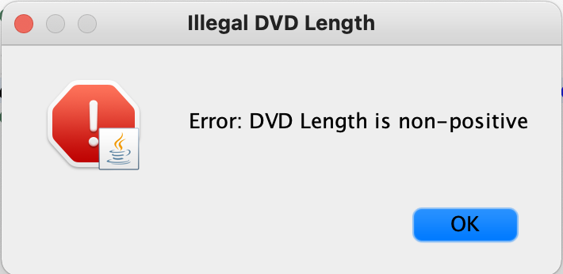

Figure .Swing dialog showing error

# Modify the **equals()** method of **Media** class

- Two medias are equal if they have the same **title**

- Please remember to check for **NullPointerException** and **ClassCastException** if applicable.

You may use **instanceof** operator to check if an object is an instance of a **ClassType**.

# Reading Document

Please read the following links for better understanding.

* Exception-handling basics:

<https://developer.ibm.com/tutorials/j-perry-exceptions/>

* Basic guidelines: Although the examples are in C++, the ideas are important.

<https://docs.microsoft.com/en-us/cpp/cpp/errors-and-exception-handling-modern-cpp?view=vs-2019#basic-guidelines>

# Update Aims class diagram

Make an exception hierarchical tree for all self-defined exceptions in Aims Project. Use class diagram in Astah to draw this tree, export it as a png file, and save them in design directory.